Dear Colleagues,

ENTSO-E **Regional Workshop with Stakeholders on “European Ten Year Network Development Plan and Regional Investment Plans 2014”** will be held on **26 March, 2014** in Bratislava. Please find enclosed the following organizational details.

**1. Accommodation:**

For your convenience, accommodation has been preliminary booked for you at the **Sheraton Bratislava Hotel***** (Pribinova 12, Bratislava) for special corporate price of 140 EUR/night**, breakfast included (web page: http://www.sheratonbratislava.sk).

**The reservations are valid until 14 March, 2014 (code-word "SEPS")**. Please contact the hotel directly via phone: +421 2 3535 0300 or e-mail: reservation.bratislava@sheraton.com in order to book your room[1].

**2. Transportation:**

**There are two international airports close to Bratislava. The international airport Milan Rastislav Štefanik in Bratislava,Slovakia and the international airport Schwechat in Vienna, Austria (50 km from Bratislava).**

**2.1 Transportation to the hotel from MRS Bratislava Airport:**

The best and the easiest way how to reach the hotel from Bratislava airport is by Taxi. There are several taxi companies operating in Bratislava. Taxi can be called by phone or it is possible to take a taxi from the airport.

Taxi services in Bratislava: with English speaking operators

* **Airport taxi**: if mentioned in advance, possible to pay also by credit cards

+421 903 777 609, +421 903 777 156, +421 903 167 777

* **Taxi Bratislava**: +421 2 16 300, + 421 907 930 300, +421 910 930 300

**2.2 Transportation to the hotel from Schwechat Vienna Airport:**

A) From Schwechat Airport you can take a bus operating between airport and Bratislava´s Central Bus Station Mlynske Nivy (Bratislava, AS) departing directly from the airport (bus fare is approx. 10,- €, tickets are sold directly in the bus; approximate travel time is 1 hour, there is a fee for a luggage 1,- € (if placed in a luggage compartment).

Bus connection from Schwechat Airport to Bratislava Central Bus Station is operated by company “Eurolines”: <http://www.slovaklines.sk/index_en.html> or,

<http://www.eurolines.sk/fileadmin/user_upload/cestovne_poriadky/mal/wien_new.pdf>

from 06:30 a.m. to 23:30 (Platform 4). From Bratislava Central Bus Station to Schwechat airport it operates between 04:40 a.m. to 22:00 (Platform 12).

From Bratislava Central Bus Station we recommend you to take a taxi to the hotel. Here are two taxi companies who operate from Bratislava Bus Station. The cars are marked with the name of the company. Before the journey ask the driver for the price.

* **PROFI** taxi (<http://www.profitaxi.sk/s_cennik>; webpage also in English),
* **BRATISLAVSKA PRVA TAXI** +421 903 757 757, +905 767 757, +421 2 16 333,

here is the logo:

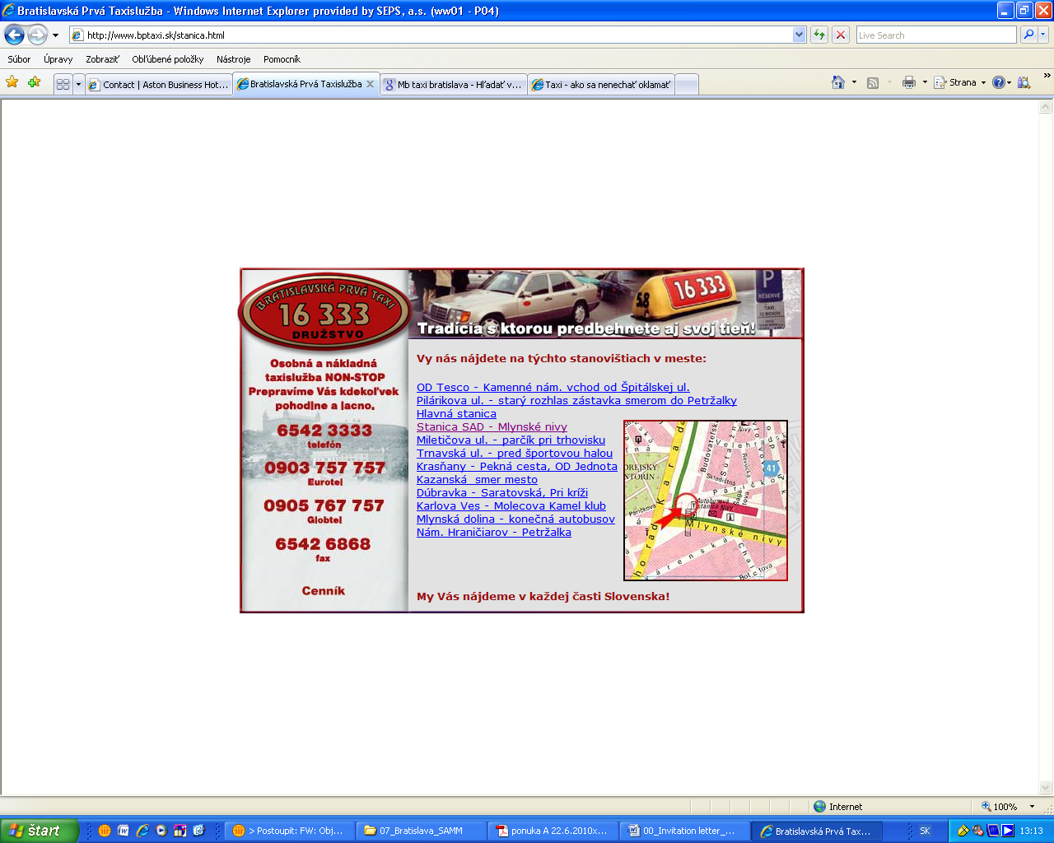

B) Directly from Schwechat Airport you can take a taxi to your hotel (price approx. € 60). For potential advance reservations see the following web page:

<http://www.airportshuttle.sk/en/> <http://www.airporttaxi.sk/kontakt/>

**3. Other useful information:**

The official web page of Bratislava, the capital of Slovakia, is <http://www.bratislava.sk/>. Useful information can be found on web page <http://www.bratislava-info.sk/> .

Should you have any additional questions regarding the meeting, accomodation or travelling, please feel free to contact me or my collegues via e-mail: [maria.dornerova@sepsas.sk](mailto:maria.dornerova@sepsas.sk), [jozef.mokry@sepsas.sk](mailto:jozef.mokry@sepsas.sk).

We look forward to meeting you in Bratislava.

1. *Please note that the meeting members are fully responsible for their hotel accommodation fees and any charges due to late cancellation of once confirmed reservation or absence due to any reason will be charged to your account.*