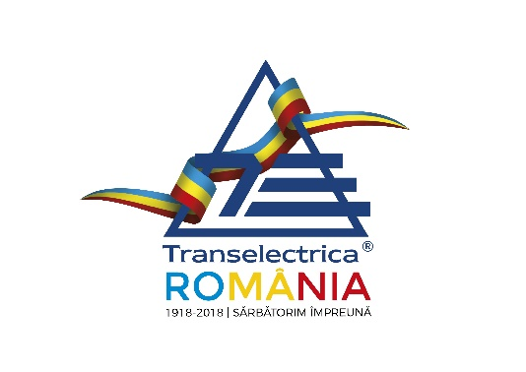

Programme granting financial assistance from the European Union for joint interest activities in the domain of trans- European power grids (Trans European Network – Energy - TEN-E)

ANNOUNCEMENT / PRESS RELEASE

PRESS RELEASE
The National Power Grid Co. Transelectrica SA has accomplished the ‘Studies on the new 400 kV double circuit overhead line (OHL) between the existent substations Smardan and Gutinas’ with the help of structural instruments
Bucharest, July 18th

The National Power Grid Company Transelectrica SA, seated in Bucharest 3, Str. Olteni no. 2-4, postal code 030786 has accomplished on 30th of April, 2018 the project ‘Studies on the new 400 kV double circuit overhead line (OHL) between the existent substations Smardan and Gutinas’, co-financed by the European Union, under the programme granting financial assistance for joint interest activities in the domain of trans-European energy grids (TEN-E), based on the European Commission Decision of 9.8.2012, «2011-E310/11-ENER/11/TEN-E-SI2.627715».
The project amounts in total to 601,385 Euros, of which the non-reimbursable financial assistance is 300,692.50 Euros, respectively 1,401,678 RON at the average exchange rate of 4.6615 RON/Euro, the official course from the info Europe site for May 2018.

The project aims at analysing the opportunity and need to build a new 400 kV line between the existent substations Smardan and Gutinas in accordance with ENTSO-E requirements, with the conclusions of other analyses conducted for the eastern part of the Romanian Power System (RPS) and taking into account the connection of installed capacities from renewable or conventional sources to the RPS.
Transelectrica is Romania’s Transmission and System Operator that manages, operates, maintains, modernises and develops the transmission grid consisting of 81 transformer substations with about 38,058 MVA capacity and 8,834.40 km of overhead lines at 110/220 kV, 400 kV and 750 kV levels, managed by 8 transmission branches.
Sole responsibility lies with the author and the Commission is not responsible for any use that may be made of the information contained therein.

Additional details can be obtained from:
Contact person: Mrs. Iulia Doina Simionescu Panait
Position: Programme Manger in European Funds Access
Phone 004 021303 5735, Fax: 021 3035660, e-mail: iulia.simionescu@transelectrica.ro

