Damas Transelectrica
New Damas system
Market Participant User Guide for Capacity Auction Participants

Revision history

Version | Date | Change description
0.01 | 01.09.2023 | Initial version

Executive Summary
This document contains a description of the basic features and procedures for the Damas Market Management System deployed by the TSO Transelectrica in the Romanian Control Area. It aims to familiarize market participants with how to operate in the (new) Damas environment with a focus on the transmission services, specifically:
- Cross-Border Capacity Allocation
For more information about the basic features of the system, refer to the “Market Participant User Guide for General Features” document.
Note that the cases below assume that the user is logged in and has sufficient user rights. If you are not registered yet in the system, refer to the “Market Participant User Guide for General Features” document. If you believe you don’t have user rights which you should have, contact a Transelectrica representative.

Content

1. Revision history 3
2. Executive Summary 4
3. Content 5
4. Cross-Border Capacity Allocation 7
4.1 Display Capacity Auction List 7
4.1.1 Description 7
4.1.2 Step by step 7
4.2 Display Capacity Auction Detail 7
4.2.1 Description 7
4.2.2 Step by step 8
4.3 Send or update bid into Capacity Auction (via visual interface) 8
4.3.1 Description 8
4.3.2 Step by step 9
4.4 Display Allocated Capacity 9
4.4.1 Description 9
4.4.2 Step by step 10
4.5 Create a Capacity Transfer 10
4.5.1 Description 10
4.5.2 Step by step 11
4.6 Accept reject or cancel Capacity transfer 11
4.6.1 Description 11
4.6.2 Step by step 14
4.7 Display Transmission Rights 14
4.7.1 Description 14
4.7.2 Step by step 15

Cross-Border Capacity Allocation

Display Capacity Auction List

Description
Authorized users are allowed to display capacity auctions existing in the system. To display them, log in to the system and in the main menu go to “Capacity Allocation” and then “Auction List”. Users may filter through the list via the “update” button on the top right side of the screen.
Some restrictions may apply depending on the authorization of the logged user.
If a user can’t see the “Auction List” in the menu, he/she is probably not authorized, in such case his/her company needs to contact a TEL representative.
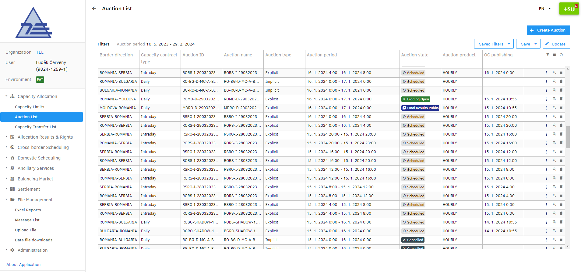
Figure 1 - Screenshot of the Capacity Auction List

Step by step
- Click “Capacity Allocation” in the Main Menu
- Click on “Auction List” under the “Capacity Allocation” in the Main Menu

Display Capacity Auction Detail

Description
Authorized market participants may display details of a Capacity Auctions, such as its timing, configuration and bids the company submitted to it. This is done via the Capacity Auction List screen, then clicking the magnification icon in the rightest row of the table, next to each auction. This will display the Auction Detail screen, where several categories of information are shown, these can be unpacked or hidden by clicking on their names.
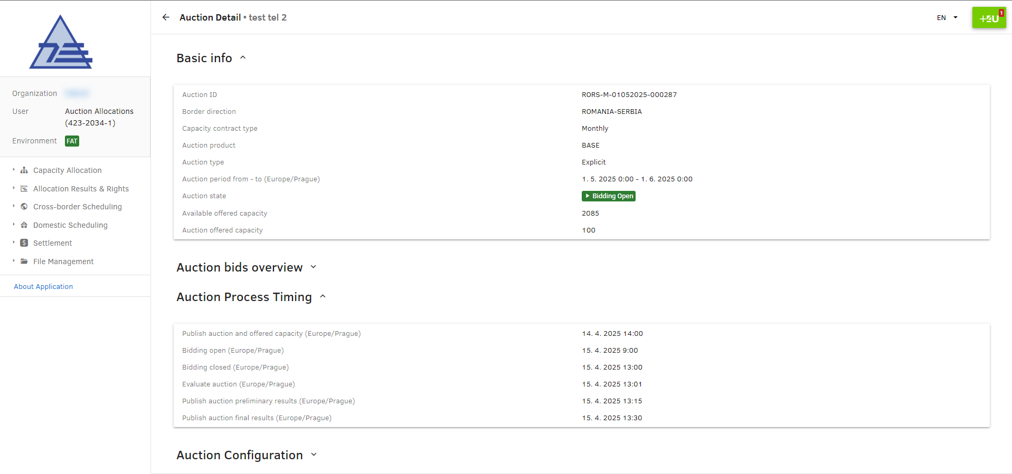
Figure 2 - Screenshot of the Capacity Auction Detail

Step by step
- Go to the Capacity Auction List
- Click the magnifying glass button next to the auction of which you want to see the detail

Send or update bid into Capacity Auction (via visual interface)

Description
Market Participants authorized to participate in Capacity Auctions may submit bids into the auctions also via the visual interface. To do this, the user needs to go to the Capacity Auction Detail of the auction for which he/she wants to submit a bid. If the auction is in a state to accept bids (i.e., “Bidding Open”), under the panel “Auction Bids Overview” is a button “Create bid”. After clicking on the button, the system opens a modal window, prompting the user to enter quantity and price per MW. Confirm the creation of the bid by the “Create” button.
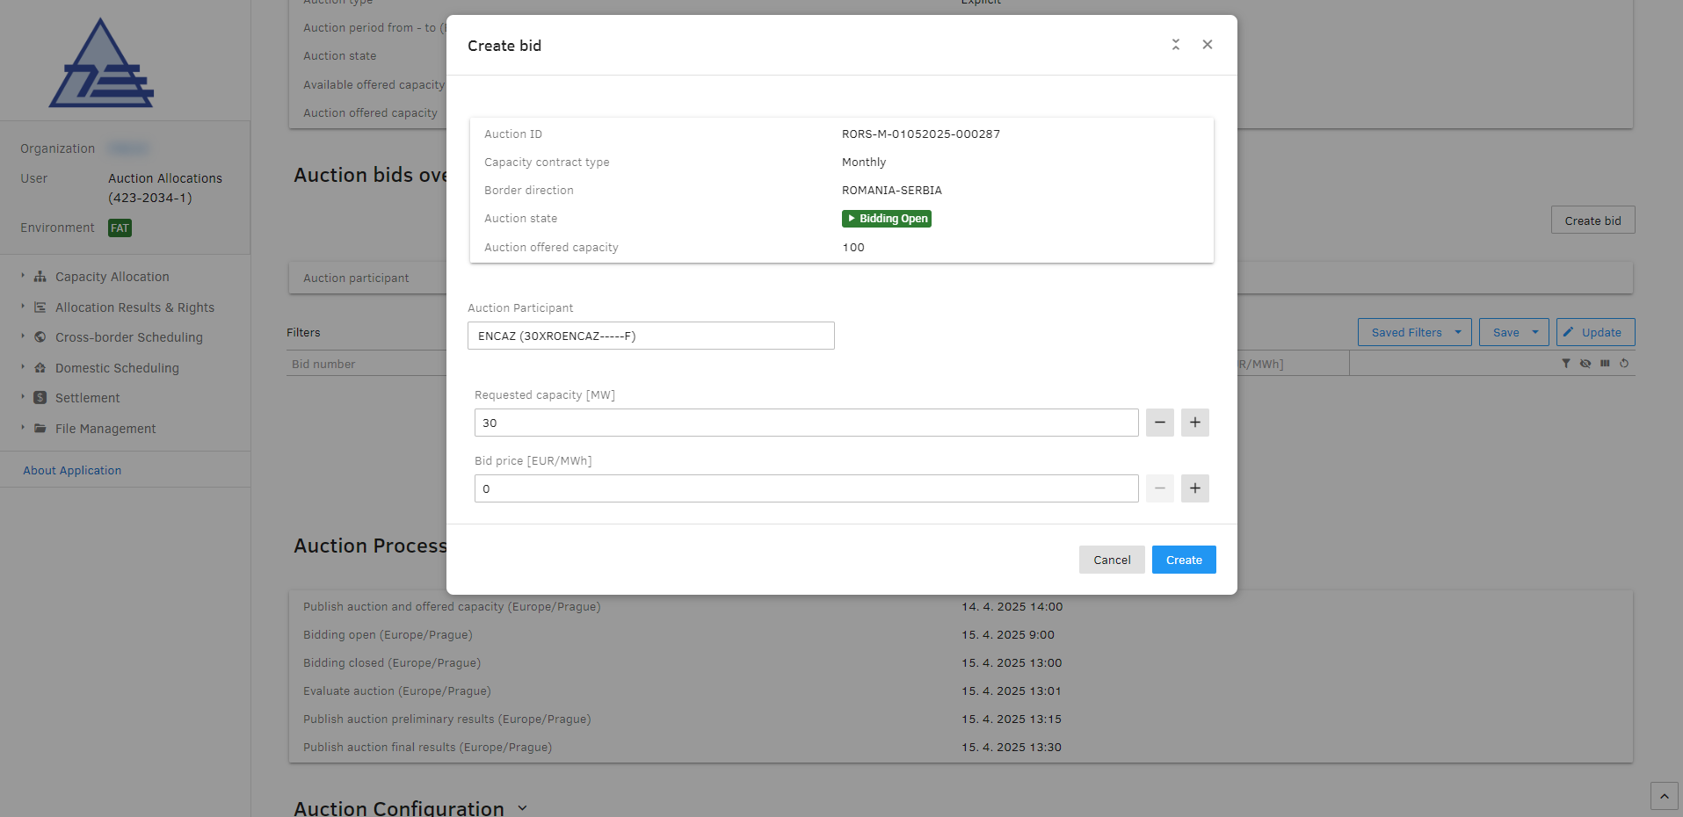
Figure 3 - Creation of a bid in a capacity auction
After the creation, the bid can be seen in the “Auction Bids Overview” panel on the Capacity Auction Detail. From this panel, the bid can also be updated (in case the bidding is still open) by clicking on the edit icon next to each bid.

Step by step
- Go to the Capacity Auction Detail
- Unpack the “Auction bids overview” panel
- Click the “Create Bid” button
- Enter quantity and price per unit of quantity
- Click the “Create” button

Display Allocated Capacity

Description
As a result of an explicit auction, some market participants may have allocated cross-border transmission capacity. To see allocated capacity in the system, an authorized user goes to “Allocated Capacity Overview” in the “Allocation Results & Rights” category in the Main Menu.
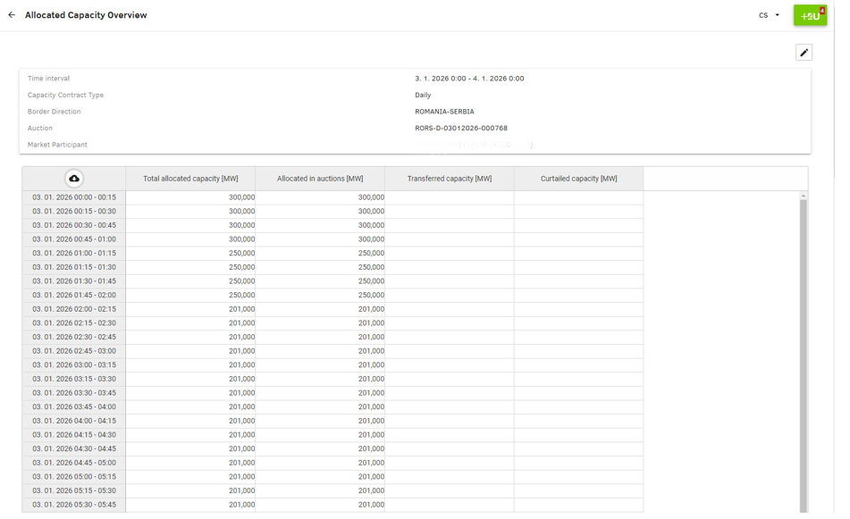
Figure 4 - Allocated Capacity Overview

Step by step
- In the main menu, unpack the “Allocation Results & Rights” category and click the “Allocated Capacity Overview”.
- On the screen, select the appropriate filters.

Create a Capacity Transfer

Description
Market participants may decide to transfer their allocated cross-border capacity to a different organization. To do that, an authorized user goes to the Auction List and from there, selects an auction from which the allocated capacity shall be transferred.
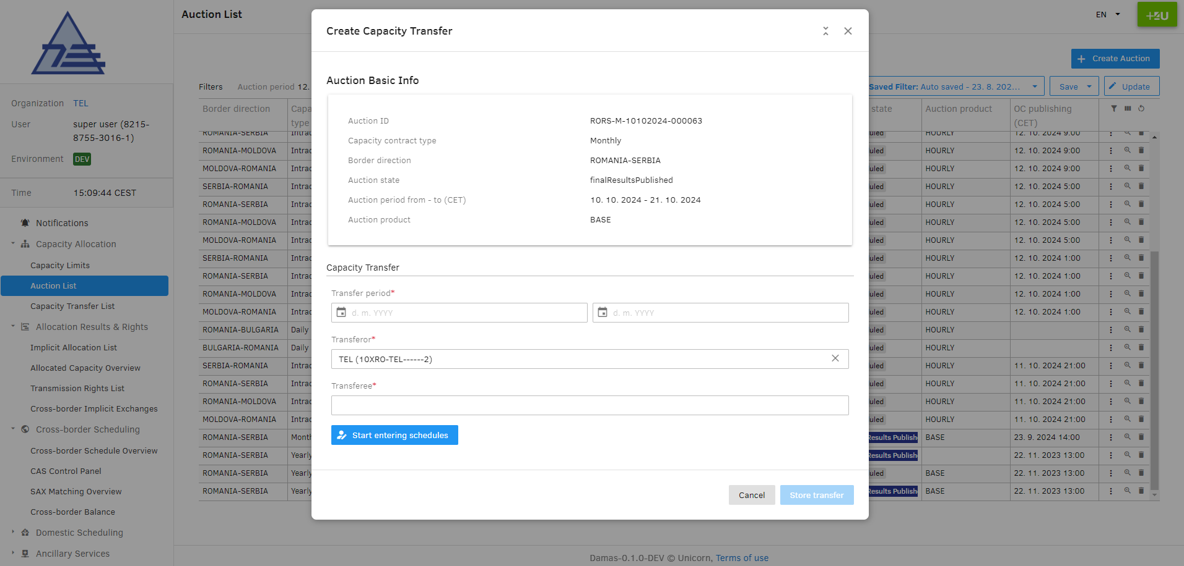
Figure 5 - Create Capacity Transfer screenshot from the system

Step by step
- In the main menu, unpack “Capacity Allocation”, then click the “Auction List”
- Find the auction from which you want to transfer the allocated capacity. It is recommended to use filters. Note that you may only transfer capacity from finished auctions (i.e. in the state “Final results Published”).
- Click the kebab menu button on a row with the desired auction and click “Create capacity transfer”
- Fill in the transfer parameters and confirm by “Store transfer”

Accept reject or cancel Capacity transfer

Description
Created capacity transfers from transferors have to be confirmed by their respective transferees. The transferor also can cancel the transfer, but only before it is accepted by the transferee. This can be done via the Capacity Transfer List screen. On this screen find the respective capacity transfer and manage it via the kebab menu. It is also possible to display details of the transfer, showing values per MTU.
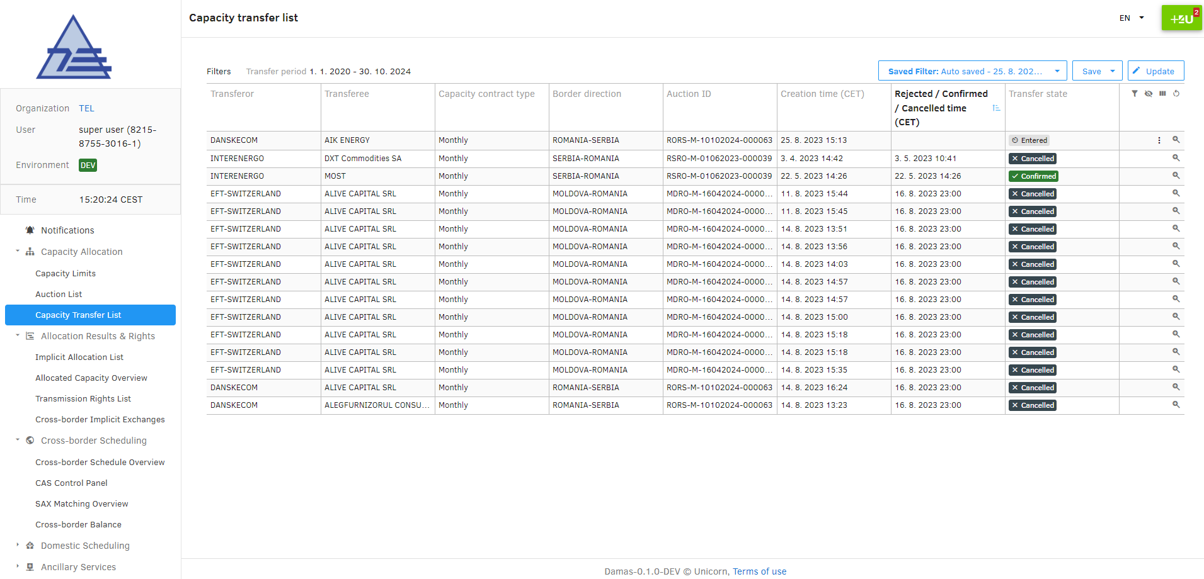
Figure 6 - Capacity Transfer List screenshot from the system

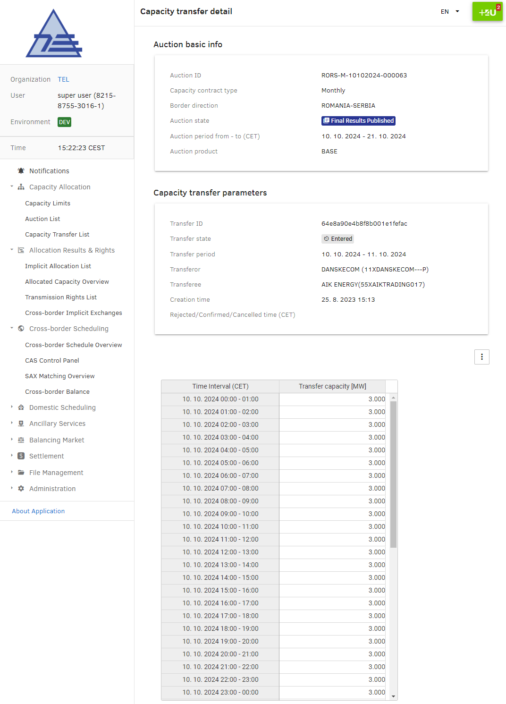
Figure 7 - Capacity Transfer detail screenshot from the system

Step by step
- In the main menu, unpack “Capacity Allocation” then click “Capacity Transfer List”
- Find the transfer that you want to change. It is recommended to use filters.
- Click the kebab menu button on a row with the desired auction and select an action you want to perform.
- You also can display details of the transfer, by clicking the detail button next to the respective transfer.
  - Note that from the detail, the transferor (before the transferee’s acceptance) can also update values per MTU of the transfer.

Display Transmission Rights

Description
As a result of the transmission capacity allocation process organized either by TSO(s) or allocation office(s), transmission rights are created. This authorizes market participants to declare cross-border electricity transportation, (i.e. nominations).
To display transmission rights, go into the system and unpack the “Allocation Results & Rights” in the main menu, then click “Transmission Rights List”, select and confirm the filtering criteria you desire and see the detail by the detail button.
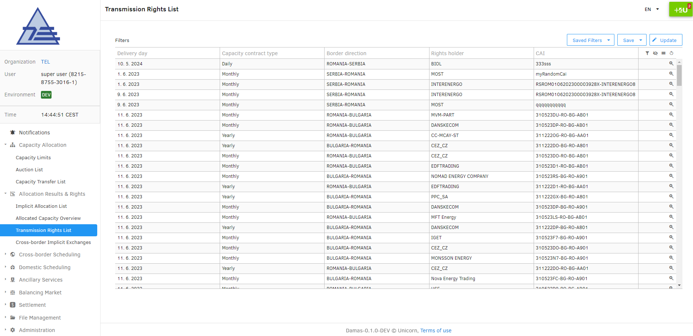
Figure 8 - Transmission Rights List screenshot from the system

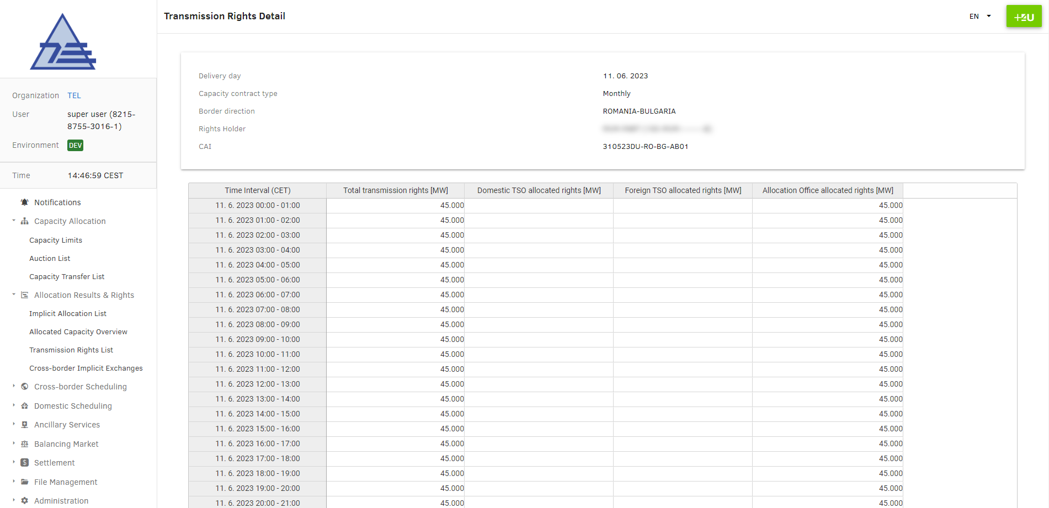
Figure 9 - Transmission Rights Detail screenshot from the system

Step by step
- In the main menu, unpack “Allocation Results & Rights”, then click the “Transmission Rights Overview”
- On the screen, select the appropriate filters.
- If you wish to display detailed values per MTU of given transmission rights, click the detail button.

