
Damas Romania
User Guide – AnS Market Participants

Unicorn © 2007 – UNICORN a.s.
V Kapslovně 2767/2, Praha 3, 130 00

Title: | Step by step for AnS Market Participants
Author: | Unicorn a.s.
Version: | 01.00
Date: | 26.2.2010
Contact: | E-mail: unicorn@unicorn.cz
 | Tel.: (+420) 221 400 111

Content
1. Content 3
2. Preface 4
2.1. REVISION HISTORY 4
2.2. APPROVALS 4
2.3. GENERAL FEATURES 5
2.3.1. Damas Login 5
2.3.2. Main Screen 6
2.3.3. Main Menu 7
2.3.4. Time Notation 8
2.4. SYSTEM TOOLS 8
2.4.1. Change User’s password 8
2.4.2. Download Certification Key 8
2.5. MESSAGES 9
2.5.1. Message Settings 9
2.5.2. Message Filter 10
2.6. AnS TENDERS & CONTRACTS 10
2.6.1. Show List of tenders 10
2.6.2. Show Tender detail 11
2.6.3. Display Tender demands 12
2.6.4. Enter/edit AnS Tender bid 13
2.6.4.1. Read only mode 14
2.6.4.2. Edit by interval mode 14
2.6.4.3. Edit by day mode 15
2.6.5. Remove AnS Tender & Contracts bid 17
2.6.6. Upload XML Bids 18
2.6.7. Contract administration 18
2.6.8. Create new Contract annex 18
3. Appendix 19
3.1. Reports 19
3.1.1. Tender demand report 19

Preface

REVISION HISTORY
Version | Date | Author | Description
01.00 | 26.2.2010 | UNICORN | User guide for AnS Market Participants

GENERAL FEATURES

Damas Login
Description
The DAMAS application is situated on these addresses:
Environment | Address
Testing Environment | https://www.market-test.transelectrica.ro
Production Environment | https://www.market.transelectrica.ro

Steps
- Enter an address to web browser (Internet Explorer 6.0 or newer).
- Warning window with security alert could be displayed. Confirm dialog by OK button.
- Dialog to choose certificate could be displayed. Cancel dialog by Cancel button.
- Enter login name and password.
- Click the OK button.

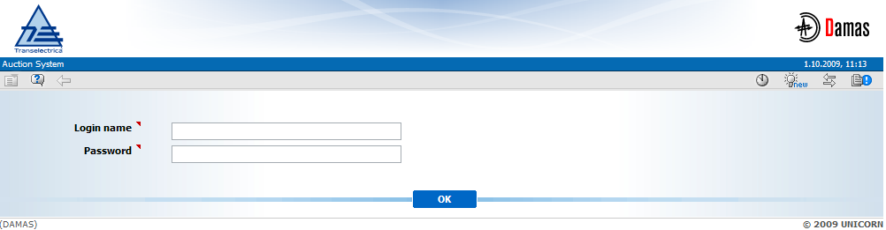
Picture 1: Login

Main Screen
Description
Main screen of Damas is displayed after logging into the system. It contains:
- Information about logged in user
- Name of the form
- Date and time of the system
- Toolbar
- Menu with a list of web forms
- Messages delivered to user
The main screen contains incoming messages and keeps history of them. The newest messages are displayed at the top of the screen. There are arrows and numbers on the bottom of a list of messages to browse the message history.
In case there is an attachment on the message there is a small icon that is situated on the right side of the screen. By clicking the icon the attachment is shown. New window or a download dialog with an appropriate file to be saved is displayed.

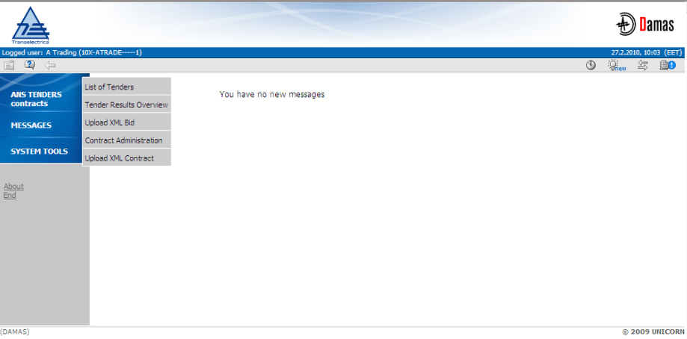
Picture 2: Main Screen

Main Menu
Description
The web forms are accessible from the main menu.
Steps
Use of main menu which is available on the main screen:
- Display main screen. Main menu is available on the left side of the screen.
- Move the mouse over main menu labels. The submenu is displayed.
- Click on an item in the submenu. The appropriate form is displayed.
Use of quick menu that is available on web form:
- Display web form.
- Select icon in toolbar. Short menu is displayed on the right side of the screen.
- Move the mouse over quick menu labels. The submenu is displayed.
- Click on an item in the submenu. The appropriate form is displayed.

Time Notation
All data displayed via web forms are in the EET time. The hours of the day are numbered from 1 to 24 (or 23 and 25 in the daylight saving time days). The first hour is a time period from 0:00 to 1:00 etc.
Some time intervals used in parameter selection are defined as Date From and Date To. Both of these days are included in selected time interval.
Example for selection of two days 01.01.2010 and 02.01.2010 (days are included):
- Date From = 01.01.2010
- Date To = 02.01.2010

SYSTEM TOOLS

Change User’s password
Description
The logged user can change his password using the Password Change form.
Steps
- Choose the menu item System Tools/Password Change.
- Enter the old password in the Old password input field.
- Enter a new password in the New password input field.
- Enter the new password again to confirm it in the Confirm password input field.
- Click OK button to save changes.

Download Certification Key
Description
The Certificate Download form enables an authorized user to download a certification key for secured SSL-protocol communication.

MESSAGES
The following functionalities are available for Auction Manager in the Messages Module:
- Display New – Recently received messages are displayed in the user account.
- Delete Selected – This menu option deletes messages selected by checkbox in the main menu. Message is deleted only from particular user account.
- Delete All – This menu option deletes all messages from the user account.
- Message Setting – It enables user to configure a user message account
- Message Filter – It enables user to view only the messages matching specified conditions.

Message Settings
Description
The Message Settings form enables to a user to configure a user message account.
Steps
- Choose the menu item Messages/Messages Settings.
- A screen Messages Settings is displayed.
- Make a setting according to your preferences.
- Specify the period for regular deletion of messages.
- Enable the possibility to receive messages by e-mail.
- Click the OK button.

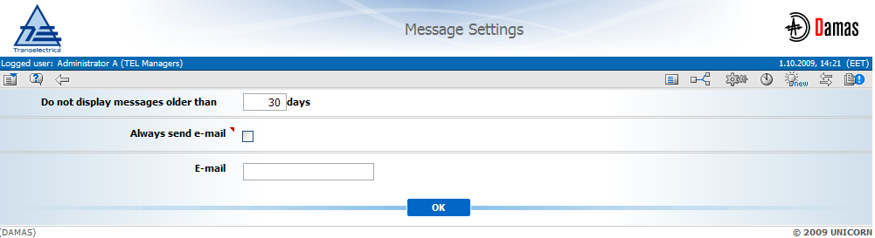
Picture 3: Message Setting

Message Filter
Description
The Message Filter form enables a user to view only the messages matching specified conditions.
Steps
- Choose the menu item Messages/Messages Filter.
- A screen Filter is displayed.
- Set up a filter according to your preferences.
- Click the OK button.

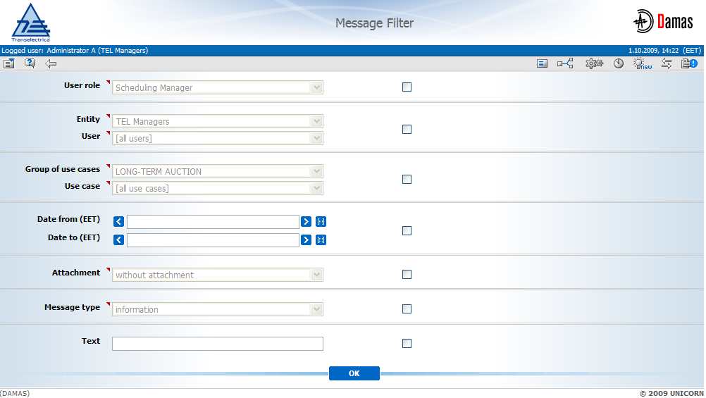
Picture 4: Message Filter

AnS TENDERS & CONTRACTS

Show List of tenders
Description
The list of all AnS tenders (except for cancelled ones) with information about their status is accessible for AnS Participant in the List of Tenders web form.
Steps
- Choose the main menu item AnS Tenders & Contracts / List of Tenders.
- Enter input parameters: Year / State (All / Unsettled / Finished).
- Press Show data button to display data due to the selected filters.

Show Tender detail
Description
AnS tenders definitions are published for AnS Participant in the Tender detail web form which is accessible from the List of Tenders form.
AnS Participant is informed about AnS Tender publishing by an information message in main menu.
Example:

Tender detail form provides all necessary details about the AnS tender divided into several sections:
- Tender identification – unique tender number, date from and date to
- Tender service demanded – there is a list of demanded services and qualitative description
- Tender process timing overview – there is a current state of the tender and there is a list of all events of the tender (e.g. Publish tender needs date, date of the Open entering of Tender bids etc.)
- Available operation section – links to the available functionalities according to the tender state.

Steps
- Choose the main menu item AnS Tenders & Contracts / List of Tenders.
- Click the link for the particular AnS tender in a Tender number column.
- The Tender Detail form is displayed with Available operations in the bottom of the form.
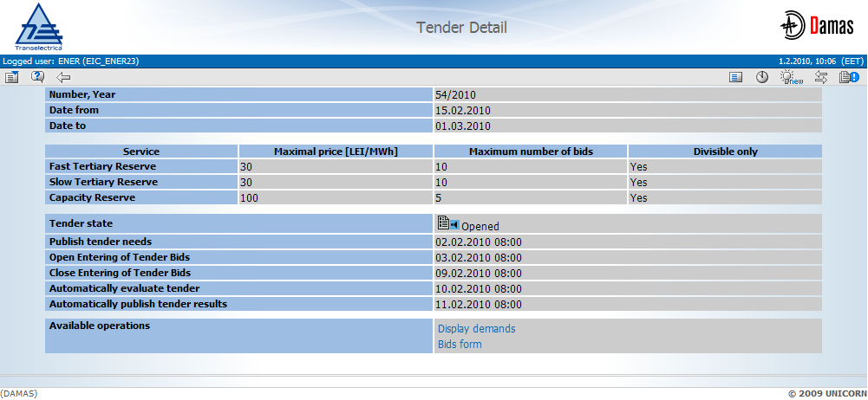
Picture 5: Tender Detail

Display Tender demands
Description
Necessary needs for AnS tender are for AnS Participant displayed in Create/Edit/Detail Demand web form. For each AnS tender there is a set of demands (necessary needs) for every single service. The demand for a service is displayed in read-only mode. In case that the procurement period of the AnS tender is longer than seven days, there is a set of control buttons for navigation through the procurement period (, , , , and ).

Steps
- Display Tender Detail (see chapter 2.5.2).
- Click the link Display demands link in the Available operation section.
- The Create/Edit/Detail Demand web form is displayed.
- In the Service combo box select a requested service.
- Click on the Show data button.
- A demand for selected service is displayed.

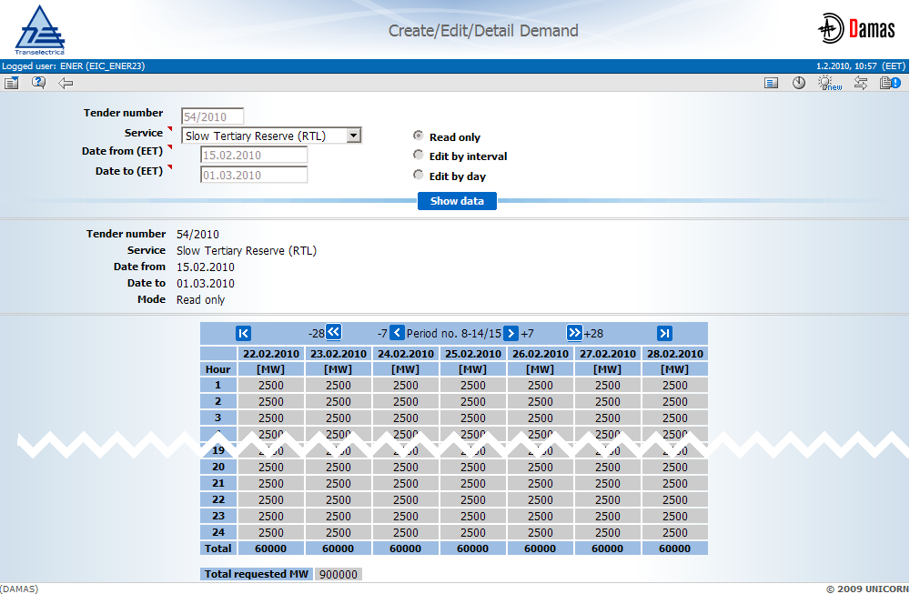
Picture 6: Tender demand

Enter/edit AnS Tender bid
Description
After the AnS tender needs are published and the AnS tender is in Opened state, AnS Participant may enter AnS tender bids via Create/Edit/Detail Bids form.

Steps
- Display Tender Detail (see chapter 2.5.2).
- Click the link Bids form in the Available operation section.
- The Create/Edit/Detail Bid web form is displayed.

The Create/Edit/Detail Bids form can be open in a several modes as is described in following chapters.

Read only mode
Description
In this mode can AnS Participant observe already submitted bids into the AnS Tender. It is not possible to enter new bids. There is overview of previously entered bids for each service available to the AnS Participant. Navigation through the bid detail is similar to the navigation in the demand detail with arrows.

Steps
- Select Read only radio button in the displayed form.
- Press Show data button.
- A table with bid overview is displayed.
- Click on the existing bid (yellow dot) to show detail of the bid for selected service.

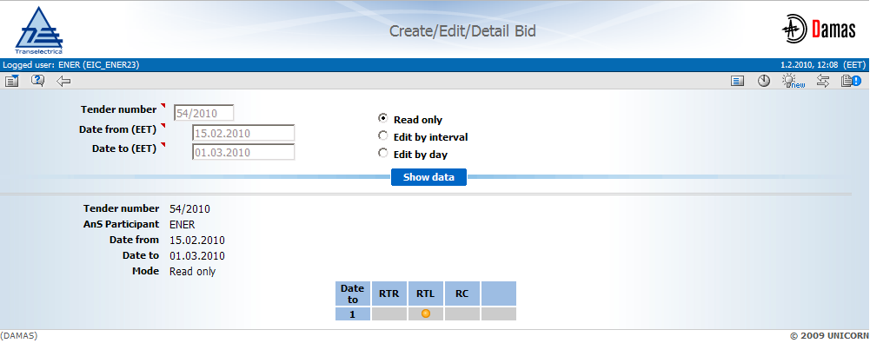
Picture 7: Show detail of the bid in read only mode

Edit by interval mode
Description
In this mode can AnS Participant enter new bids or edit existing bids by interval. It is possible to enter offered quantity and price on the interval within the tender procurement period. After a bid confirmation (Save button pressed) the bid is sent to the server for validation and submitting.
In case the interval consists of previously bid variable amounts, the form is displayed with red colored background of input cells.

Steps
- Select Edit by interval radio button in the displayed form.
- Select requested time interval in the Date from and Date to input box.
- Press Show data button to display the bids overview.
- Click on the Add bid button in the bids overview table to add new bid for all demanded services.
- Click on the empty cell in the service column by the requested service.
- Add values into the form (offered quantity and price per unit).
- Press Save button to sent the bid to the server for validation.
- Check an information message in the main menu.

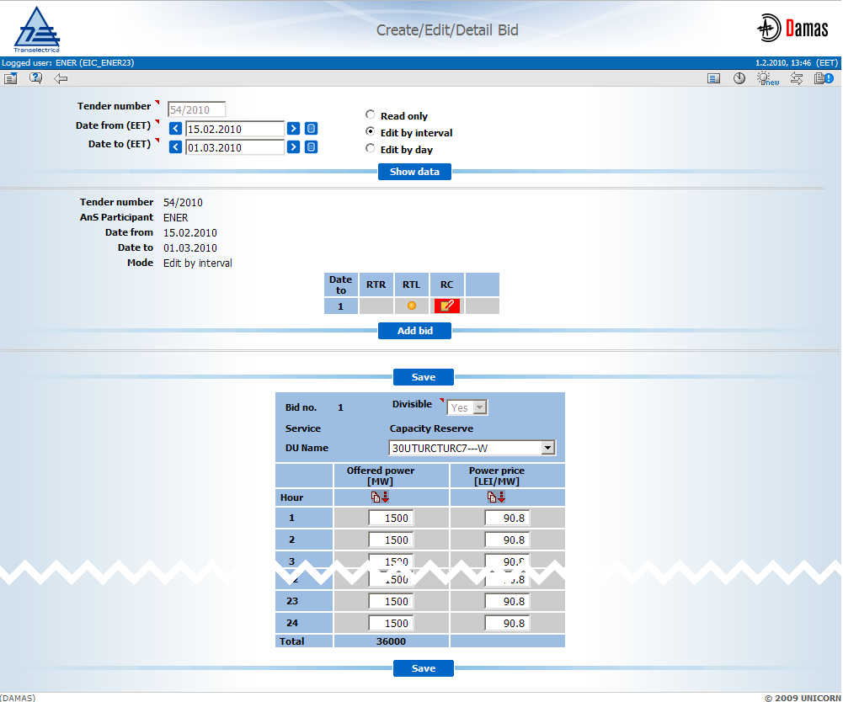
Picture 8: Show detail of the bid in Edit by interval view

Edit by day mode
Description
In this mode can AnS Participant enter new bids or edit existing bids with different offered quantity and price for each day. After a bid confirmation (Save button pressed) the bid is sent to the server for validation and acceptance.

Steps
- Select Edit by interval radio button in the displayed form.
- Select requested time interval in the Date from and Date to input box.
- Press Show data button to display the bids overview.
- Click on the Add bid button in the bids overview table to add new bid for all demanded services.
- Click on the empty cell in the service column by the requested service.
- Add values into the form (offered quantity and price per unit)
- Change day for entering bids (navigate through with arrows).
- Repeat step (6) – add values
- Press Save button to sent the bid to the server for validation

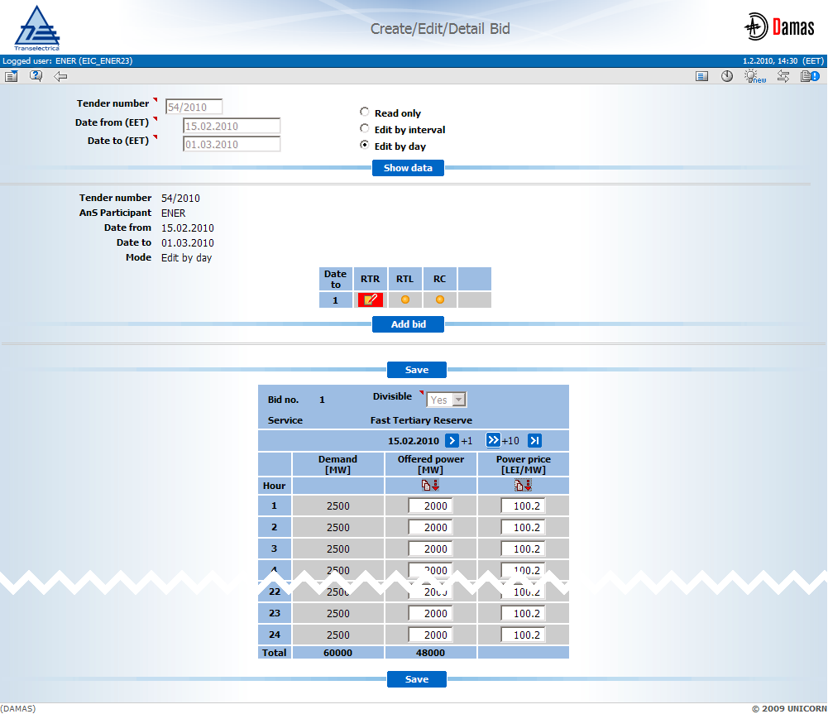
Picture 9: Show detail of the bid in Edit by day view

Remove AnS Tender & Contracts bid
Description
In case the amount (either it is quantity or price) are wrong or entered incorrectly and need to be removed (nullified).
Bids which weren’t submitted could be removed from the create/edit/detail bid form by clicking the icon in the bids overview section. Bids for all services in selected row of bids will be removed.
To cancel submitted bids it is necessary to edit and submit them with zero values.

Upload XML Bids
Description
The Upload XML Bids form enables an AnS Participant to upload an XML file with AnS tender bids to the system. The XML file structure is available as an attachment to this document.

Steps
- Choose the menu item AnS Tenders & Contracts / Upload XML Bids
- Click the Browse button to find a location of the XML file to be uploaded.
- Press OK button to upload the XML file.
- Check an information message in the main menu.

Contract administration
Description
The Contract Administration web form is used by AnS Participant to display contract annex of particular type. The user of Tender Operator is allowed to create and edit a contract annex of transferred type. It is also allowed to approve or reject the contract of Transferred type.
The form can be displayed in three different modes:
- Read only mode (default) - in this case are data displayed in read only mode and the user cannot make any changes to displayed data. If the selected time period period is longer than 10 days, it is displayed the button for switching between the single 7-day periods (, , , , and ). In this case is also displayed a button for jump to next (or previous) seven days of the procurement period and also the button for jump to the last (or first) seven days of the procurement period.
- Edit by interval mode – in this case are data displayed in edit mode by interval. Data can be modified for whole selected time interval. In the Selection Parameters section, the user specifies the interval with identical hourly values. The user specifies values for each hour of the day, which are automatically copied for the whole interval. When the data for each hour are different than the minimum value is displayed and the cell’s background is highlighted with a red color.
- Edit by day - in this case are data displayed in edit mode by days. Data can be modified for single day in a 10-day period. If the procurement time period is longer than 10 days, it is displayed the button for switching between the single 10-day periods (, , , , and ). In this case is also displayed a button for jump to next (or previous) seven days of the procurement period and also the button for jump to the last (or first) seven days of the procurement period.

Steps
- Choose the main menu item AnS Tenders & Contracts / Contract Administration.
- Select the Date from and the Date to to specify the time interval.
- In the Service combo box select a requested service.
- In the Contract annex type combo box select a requested type of a contract annex (Regulated, Bilateral, Supplementary, Transferred, Tender).
- Select Contract annex state from the combo box
- In the radio button select a display mode (Read only, Edit by interval
or Edit by a Day).
- Press Show data button.
- The overview table with contract annexes is displayed.
- Select one annex from the overview table with contract annexes.
- Press Show Detail button do display the detail of selected contract annex.

Steps for transferred contract annex approval/rejection as a transferee
- Choose the main menu item AnS Tenders & Contracts / Contract Administration.
- Select the Date from and the Date to to specify the time interval.
- In the Service combo box select a requested service.
- In the Contract annex type combo box select a requested type of a contract annex (Transferred).
- Select Contract annex state from the combo box
- In the radio button select a display mode (Edit by interval
or Edit by a Day).
- Press Show data button.
- The overview table with contract annexes is displayed.
- Select one annex from the overview table with contract annexes.
- Press Show Detail button do display the detail of selected contract annex.
- In the overview table with contract annex is displayed State of approval column.
- Click on the functional icon in the particular row to change the state of icon to Approve/Reject.
- Press Save button.
- The state of a respective transferred contract annex is changed to Approve/Reject.

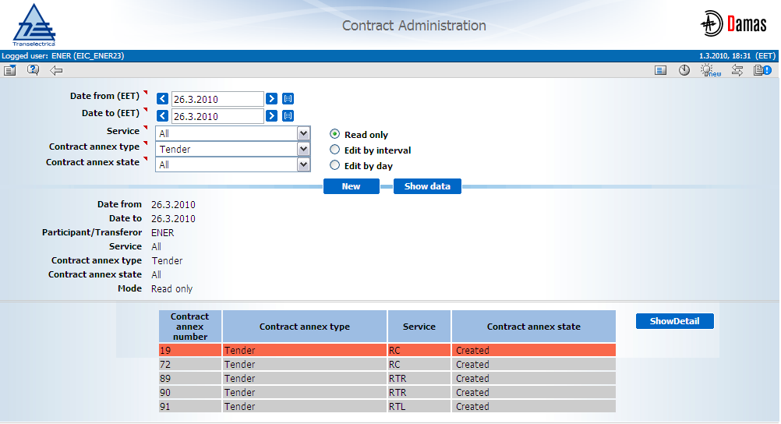
Picture 10: Contract Administration – read only
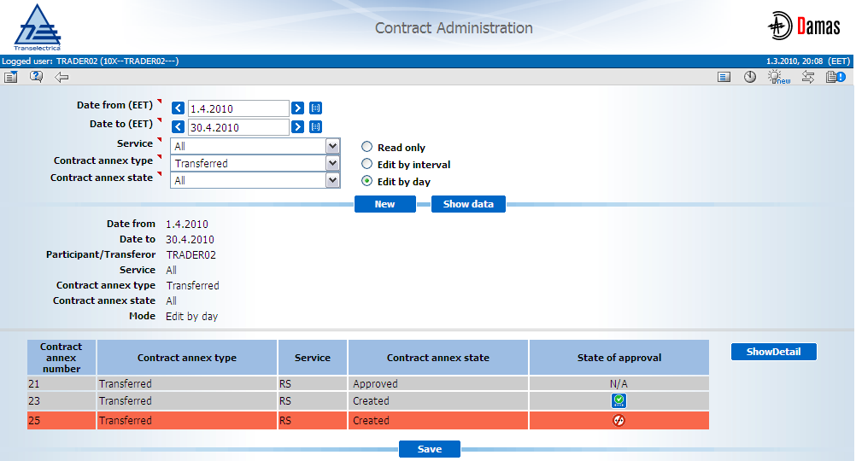
Picture 11: Contract Administration – approve/reject transferred contract annex before save
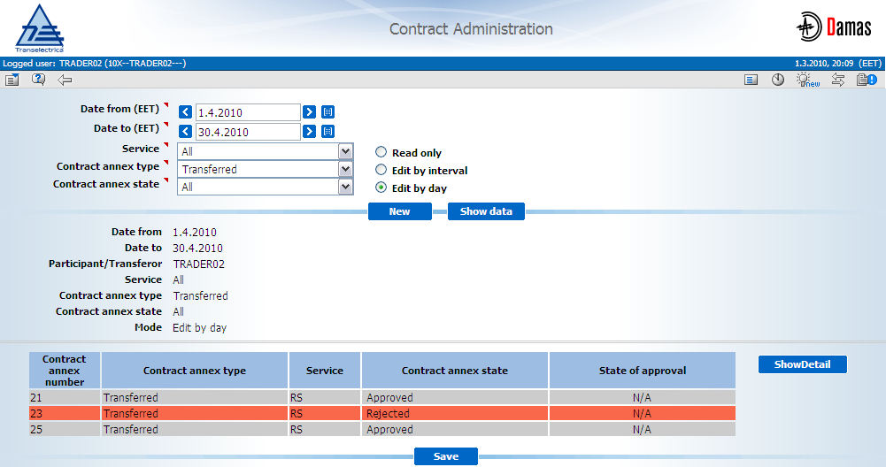
Picture 12: Contract Administration – approve/reject transferred contract annex after save

Create new Contract annex
Description
The Create Administration form is used by AnS Participant to display contract annex of particular type and manually create a contract annex of Transferred type.
Steps for creation contract annex of Transferred type
- Choose the main menu item AnS Tenders & Contracts / Contract Administration.
- Press New button.
- Select the Date from and the Date to to specify the procurement period of a new contract annex.
- In the Contract number combo box select a number of source contract from low office to which the source contract annex belongs.
- Press List update button to load the respective contents of following combo boxes.
- In the Contract annex type combo box select a type of the new contract annex (Transferred).
- In the Transferee combo box select AnS Participant which is transferee of a new contract annex.
- In case of RC service select particular DU in the Target DU Name combo box which is transferee of a new contract annex.
- Press Show data button.
- Enter transferred quantity.
- Press Save button.

AnS Market Participant is informed about the contract annex receiving by an information message in the main menu.
Example:
Picture 13: Create contract – message detail

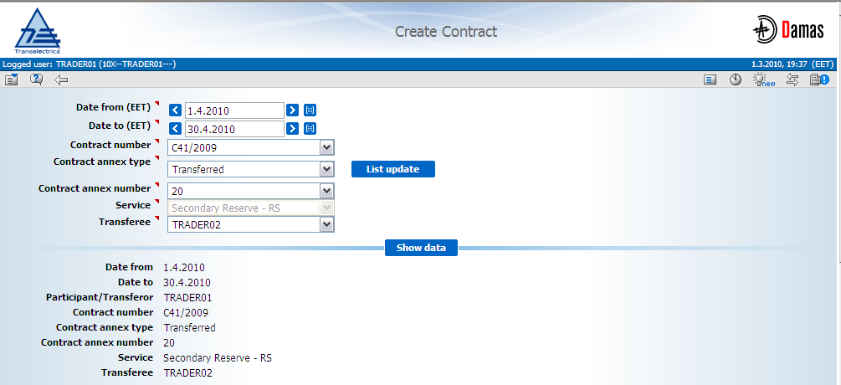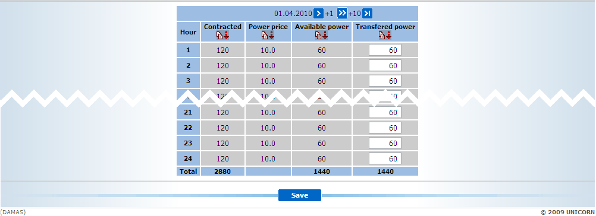Picture 14: Create contract

